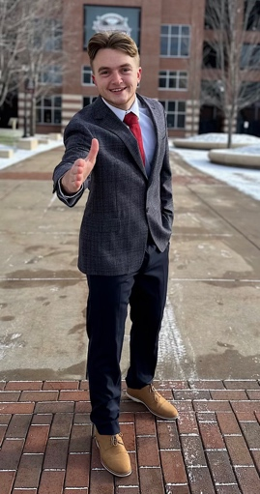**Reid T. Frederickson**

Kansasville, Wi | 262-332-3005 | [reid.frederickson52@gmail.com](mailto:reid.frederickson52@gmail.com)

Personal Website: <https://www.reidandgreet.com>

**University of Wisconsin – La Crosse** |Bachelor of Science: Marketing

Minor: Professional Leadership Development.

Graduation Date: May 2025

**Experience**

**Rolling Cones Ice Cream Truck – General Manager.** *June 2021 – Present*

* Managed all operations for a growing ice cream truck business (events + mobile route), serving 15–30 events/month and one event with over 3,000 customers.
* Led hiring, scheduling, inventory, and daily logistics across two trucks; ensured consistent branding and route reliability.
* Drove customer growth through advertising on Facebook, Google, and local outreach; expanded operations year-over-year.
* Handled B2C sales negotiations, event execution, and fast-paced customer service

**7 Mile Fair – Sales Associate (Electronics Vendor)** *December 2020 – January 2025*

* Sold cable box streaming devices in a high-pressure, negotiation-heavy environment.
* Used SPIN-style questioning to overcome objections and drive repeat, multi-unit, and wholesale sales.
* Built lasting customer relationships through genuine connections, confident communication, product knowledge, and sales resilience.
* Identified upsell opportunities and used urgency-based strategies to increase average sales.

**GNC – Sales Associate.** *August 2023 – March 2024*

* Consistently met loyalty sign-up goals using needs-based, relationship-first selling
* Balanced multitasking demands such as assisting customers, completing GNC University training, and managing in-store responsibilities
* Logged sales activity in Excel and supported daily store operations, from fulfillment to closing procedures.

**Collegiate Involvement**

**Sales Competition** – Hormel Role Play (Spring 2025) - Presented Ribbon Pepperoni to wholesaler in judged role-play; praised for rapport, tone, and delivery.

**Leadership Development Minor Ambassador** - Promoted minor across campus and student organizations